How to install sql server

- Double click on SQL server setup file,
- It will configuring all components
- It scan your computer configurations
- Then the sql server installation wizard will be appear,click Next button.It copies all the files
- Give the registration information like name,and company details then click next
- Select all components to install and click next.
- Select Default instance radio button option and click next.
- Then select the service account details here click on “Use the built in system account” and select all check boxes and click next button
- Then authentication mode window will be appear here select “Mixed mode radio button and enter the password it is by default “123” only. Then click next button
- Click On Next Button until you get the finish --- Rest of all the options are default only
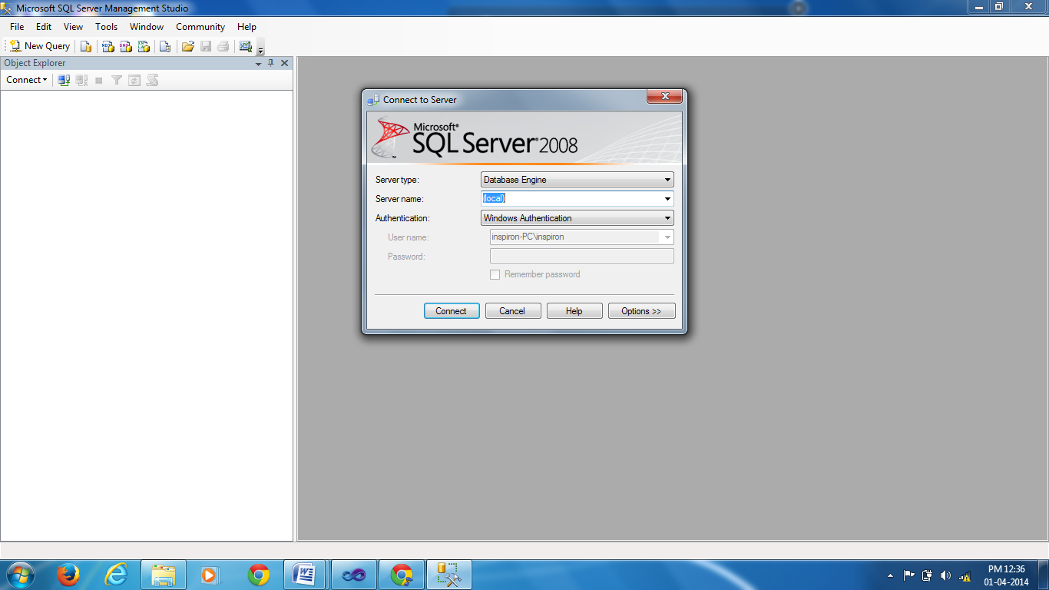

Fig: The final IDE of Sql Server 2008.

When you click on the connect button the sql server data base is connected to your .net

How to install .net

- Click on setup file in the .net software.
- It will take several minutes to install, give the name to the .net for the administrator name.
- Then the installing components window will be appear select all components and then click next button until finish button appear.
- Finally the .Net dictionary files are copied into your system then click close button,then the fallowing IDE will be appear which is Microsoft Visual Studio start page.

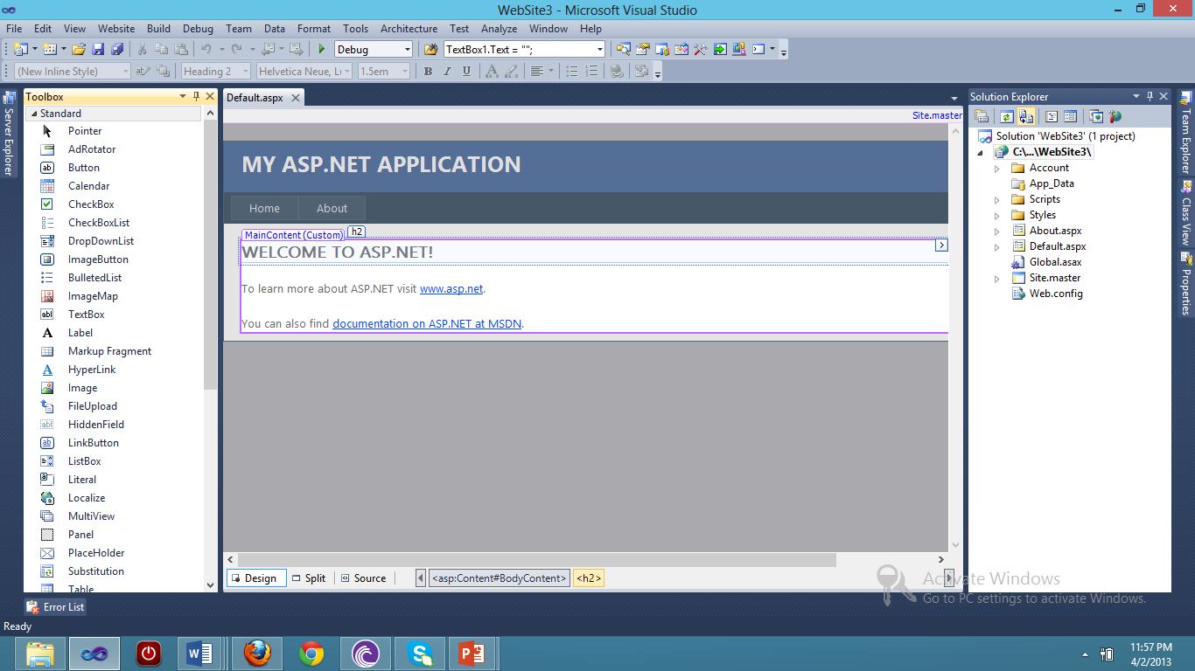

Fig: The Microsoft Visual Studio start page

When you are click on file\New\Website , give the website name,then the empty default website will be appear which has the tool box, solution explorer tabs as shown in the above figure.

How to deploy the data base files

- Copy the database files like mdf and ldf files into C:\Program Files\Microsoft SQL Server\MSSQL.1\MSSQL\Data
- Paste the database files into specific computer C:\Program Files\Microsoft SQL Server\MSSQL.1\MSSQL\Data
- Select Sqlserver Management Studio Option in start menu
- Connect with Windows Authentication, Click on the connect button
- Select Sqlserver and right click and then select properties
- Select Sqlserver and windows authentication mode radiobutton and click on ok
- Reset the password
- Select status page guest and enabled radio buttons
- Right click on server and select disconnect and then
- Click on connect and select database Engine
- Right click on the database and select attach
- Click on the Add button to attach the mdf files
- Select the relevant .mdf file and click on ok button
- Both the database files are attached just click on ok button
- Select the database and view its tables

How to execute the project

- Copy the code from the CD.
- Paste the code at C:\Users\admin\Documents\Visual Studio 2010\Websites
- Open the visual studio 2010
- Click on the file\open
- Select the project on the C:\Users\admin\Documents\Visual Studio 2010\Websites
- Right click on start page on your project click “set as start page” and press F5.

